**CHEAT SHEET 3: DISCRIMINANT ANALYSIS**

*Formula*

Works by using a classification rule that assigns an object to the group with the highest conditional probability.

*Plot*

*Linear*

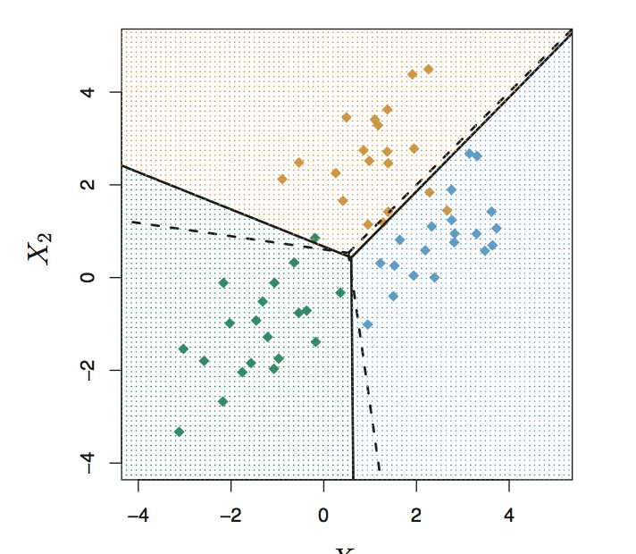

*Quadratic*

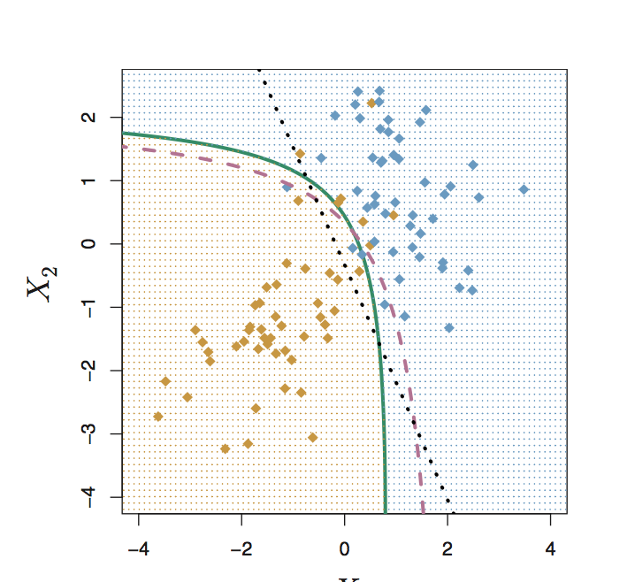

*Suitable for:* Predicting the values of a categorical variable, where the groups are already known or pre-determined, using any kind of variables (nominal, ordinal, interval, ratio).

*Procedure:* **(1) Explore the relationships** using visualisation and correlation matricies; **(2) Run the model; (3) Examine** the model fit, using test/train model data or other cross- validation methods.

*Actions for improving the model:* **(1) Change the posterior probability** (typically set at 0.5) to deal with misclassification of much smaller groups;

*Considerations*: **(1)** LDA assumes that the observations within each class come from a **normal distribution.**